

**UNIVERSIDAD TECNOLÓGICA DE**

**SAN LUIS RIO COLORADO**

**GUIA**



**MTRO. AURELIO FLORES**

**ALUMNO: VICTOR MANUEL GALVAN COVARRUBIAS**

**ING. EN DESARROLLO Y GESTIÓN DE SOFTWARE**

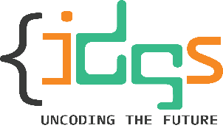San Luis Rio Colorado, Sonora Octubre, 2022

**Artificial intelligence** is the simulation of human intelligence processes by machines, especially computer systems. Specific applications of AI include expert systems, natural language processing, speech recognition and machine vision.

In general, AI systems work by ingesting large amounts of labeled training data, analyzing the data for correlations and patterns, and using these patterns to make predictions about future states. In this way, a Chabot that is fed examples of text chats can learn to produce lifelike exchanges with people, or an image recognition tool can learn to identify and describe objects in images by reviewing millions of examples.

**Machine learning** is a branch of artificial intelligence (AI) and computer science which focuses on the use of data and algorithms to imitate the way that humans learn, gradually improving its accuracy.

**Data mining** is defined as a process used to extract usable data from a larger set of any raw data. It implies analysing data patterns in large batches of data using one or more software. Data mining has applications in multiple fields, like science and research. As an application of data mining, businesses can learn more about their customers and develop more effective strategies related to various business functions and in turn leverage resources in a more optimal and insightful manner.

**Big Data** is a collection of data that is huge in volume, yet growing exponentially with time. It is a data with so large size and complexity that none of traditional data management tools can store it or process it efficiently. Big data is also a data but with huge size.

1. Artificial Intelligence
   1. Voice Assistants
   2. Autonomous Vehicles
   3. Facial Recognition
2. Machine learning
   1. Videos Surveillance
   2. Social Media
   3. Email Spamming
3. Data mining
   1. Retail Industry
   2. Crypto currency
   3. Criminal Investigation
4. Big data.
   1. Transportation
   2. Education
   3. Government
5. Pandas



Pandas is a Python package that provides fast, flexible, and expressive data structures designed to make working with "relational" or "labeled" data both easy and intuitive. It aims to be the fundamental high-level building block for doing practical, real world data analysis in Python.

conda install pandas

1. Numpy



NumPy is a Python library used for working with arrays.

It also has functions for working in domain of linear algebra, fourier transform, and matrices.

NumPy was created in 2005 by Travis Oliphant. It is an open source project and you can use it freely.

NumPy stands for Numerical Python.

1. Scipy



SciPy in Python is an open-source library used for solving mathematical, scientific, engineering, and technical problems. It allows users to manipulate the data and visualize the data using a wide range of high-level Python commands. SciPy is built on the Python NumPy extention. SciPy is also pronounced as “Sigh Pi.”

1. Scikit-learn



Scikit-learn (Sklearn) is the most useful and robust library for machine learning in Python. It provides a selection of efficient tools for machine learning and statistical modeling including classification, regression, clustering and dimensionality reduction via a consistence interface in Python. This library, which is largely written in Python, is built upon NumPy, SciPy and Matplotlib.

1. Matplotlib



Matplotlib is a comprehensive library for creating static, animated, and interactive visualizations in Python. Matplotlib makes easy things easy and hard things possible.

1. TensorFlow

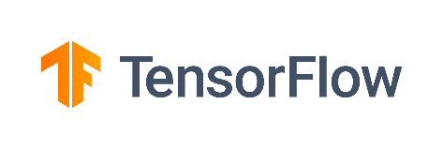

TensorFlow gives us an interactive multiplatform programming interface which is scalable and much stable when compared to other **deep learning** libraries available, which are still very experimental.

